VIDYANIDHI UNIVERSITY EXAMINATION MANAGEMENT SYSTEM

PROJECT REPORT

Submitted By
Name: CHINMAY SANE
Roll No: 24102C0022
College: VIDYALANKAR INSTITUTE OF TECHNOLOGY
Academic Year: 2025-26

1. Introduction
Vidyanidhi University conducts examinations for a large number of students from various affiliated colleges. Managing examination schedules, student registrations, subject allocations, examination centers, fee collection, and result processing manually is time-consuming and prone to errors.
The purpose of this project is to design and develop a Database Management System (DBMS) that automates the examination process and provides efficient management of student records, examination scheduling, fee collection, and result generation.
The proposed system helps different departments of the university such as Academic, Administration, and Finance by generating reports and maintaining accurate records.

2. Objectives
The objectives of the project are:
- To maintain student information.
- To maintain college and degree information.
- To manage subjects and examination schedules.
- To allocate examination centers.
- To maintain examination fee records.
- To store and process examination results.
- To generate reports for academic, administrative, and finance departments.
- To reduce paperwork and improve efficiency.

3. Scope of the Project
The system covers:
- Student Registration
- College Management
- Degree Management
- Subject Management
- Examination Scheduling
- Examination Center Management
- Result Processing
- Fee Management
- Report Generation
The system is scalable and can accommodate future growth in university activities.

4. Problem Statement
A large university with multiple affiliated colleges conducts examinations in various subjects. Managing examination data manually leads to duplication, inconsistency, and difficulty in generating reports.
The university requires a centralized database system to manage:
- Student Records
- Subjects
- Examination Centers
- Exam Schedules
- Exam Fees
- Examination Results
The system should support multiple departments and generate useful reports.

5. Database Design
The database contains the following entities:
- College
- Degree
- Student
- Subject
- Subject Section
- Exam Center
- Exam Schedule
- Student Subject
- Result
- Exam Fee
- Expenditure
Primary Keys and Foreign Keys are used to maintain data integrity and relationships between tables.

6. Normalization

First Normal Form (1NF)
All repeating groups were removed and each field contains only atomic values.
Example:
Student and Subject information are stored separately.

Second Normal Form (2NF)
Partial dependencies were removed by separating subject information from student information.
Example:
Student and Subject tables are linked using Student_Subject table.

Third Normal Form (3NF)
Transitive dependencies were removed.
Example:
College details and Degree details are stored in separate tables rather than being repeated in Student table.
The database is normalized up to Third Normal Form (3NF).

7. Entity Relationship Diagram
The ER Diagram represents relationships among:
- Student
- College
- Degree
- Subject
- Exam Center
- Exam Schedule
- Result
- Exam Fee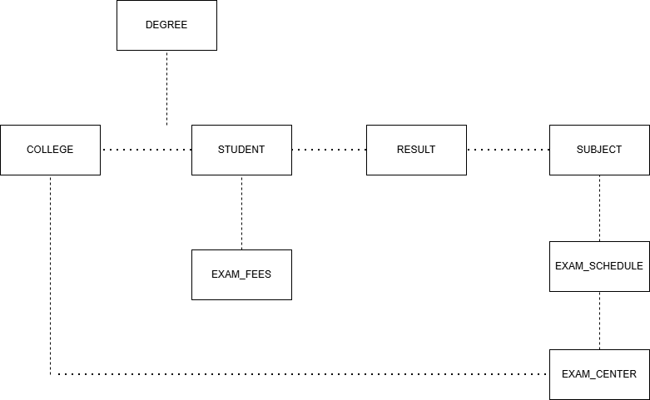

8. Table Description

Student
Stores student information including exam seat number, name, degree, and college details.

College
Stores details of affiliated colleges.

Degree
Stores information about degree programs.

Subject
Stores subject information offered by the university.

Exam Center
Stores examination center information.

Exam Schedule
Stores examination dates and timings.

Result
Stores marks and grades obtained by students.

Exam Fee
Stores fee payment details.

Expenditure
Stores examination-related expenses.

9. Reports Generated

Academic Reports
- Student Performance Report
- Subject Wise Result Analysis
- Pass Percentage Report
- Rank List

Administrative Reports
- Center Wise Student Distribution
- Subject Wise Student Count
- Examination Schedule Report

Financial Reports
- Fee Collection Report
- Pending Fee Report
- Expenditure Report
- Profit/Loss Report

10. Advantages of the System
- Faster data processing
- Reduced manual errors
- Better data security
- Easy report generation
- Efficient examination management
- Improved decision making
- Centralized database system

11. Future Enhancements
The system can be extended by adding:
- Online Examination Module
- Student Login Portal
- Faculty Login Portal
- Online Fee Payment Gateway
- SMS and Email Notifications
- Attendance Management
- Hall Ticket Generation

12. Conclusion
The Vidyanidhi University Examination Management System successfully automates examination-related activities. The database is normalized up to Third Normal Form (3NF), ensuring data consistency and reducing redundancy.
The system provides an efficient solution for managing students, examinations, results, and finances while supporting future expansion of university operations.

